ABINAV S T

230701007

EXP NO:8 PRODUCER CONSUMER USING SEMAPHORES

PROGRAM

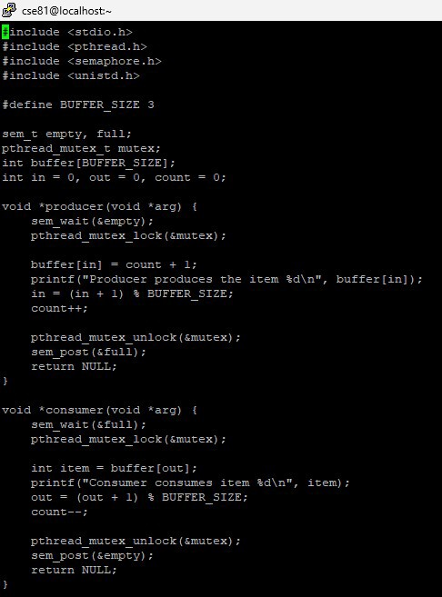

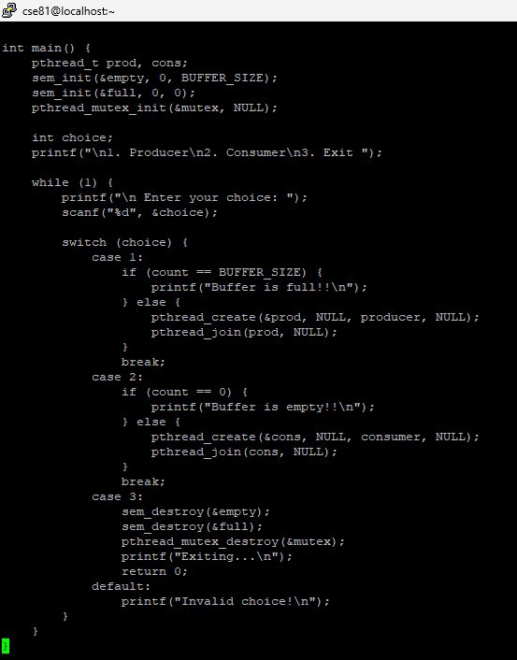

OUTPUT

